**Written Purpose Statement**

**Final Project**

**City Bus Management**

**The Application’s purpose is to manage the buses of a local transit . The application can add a bus,delete it,update the route, add driver to the bus , show recently added bus and show all of the record of a particular bus.**

**The application creates a txt file named after a bus number that is added everytime we add a new bus. It is unique number and is used to delete the bus , update the route through it and also appends the data of the driver ie. ID ,first name,last name to the file.**

The file is saved as the bus number to identify different buses

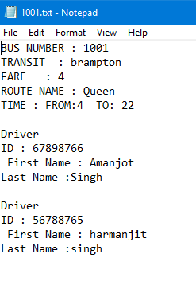

There can be more than one Driver to drive the bus. They are identified by their ID.

**The Windows Form Application contains 7 forms named**

1. **Main.cs**
2. 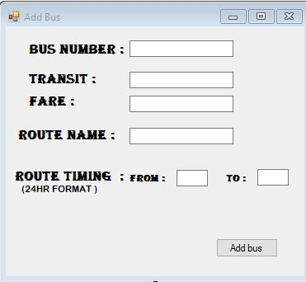**addBus.cs**
3. 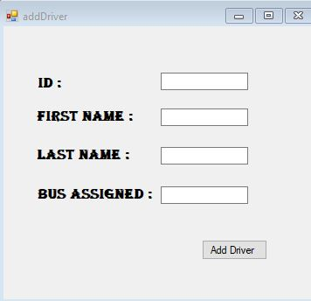**Add Driver.cs**
4. **Delete Bus.cs**

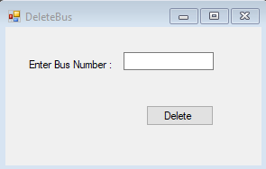

1. **Update.cs**

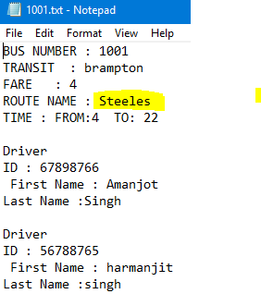

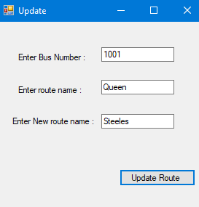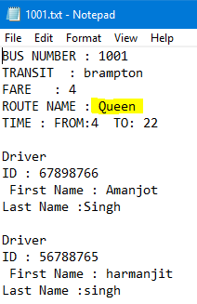

1. **Recent.cs**

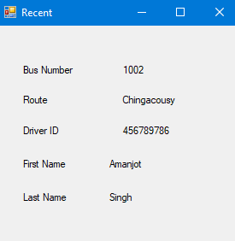

1. **showAll.cs**

